Assignment 2- Case Study (8995-G level Task)

Stage 5 Lab Activities

Refactoring SmartCare into a Layered Architecture
HUMAN ANALYSIS -> REFACTOR -> AI REVIEW -> VERIFY | 1 hour

A - Inspect SmartCare v0.4
Identify domain, workflow, data-access and presentation responsibilities currently mixed together.
Responsibility type | Problem
Domain | Appointment.cancel() and status rules are correctly placed.
Workflow | Booking, overlap checking and scheduling logic have no dedicated home.
Data Access | No repository exists; objects live only in memory with no clear persistence boundary.
Presentation | No layer exists yet, but any print or input logic added to domain classes would be a violation.

B - Propose Architecture
Draw Presentation -> Service -> Domain, with Service using a Repository abstraction and Persistence implementing it. 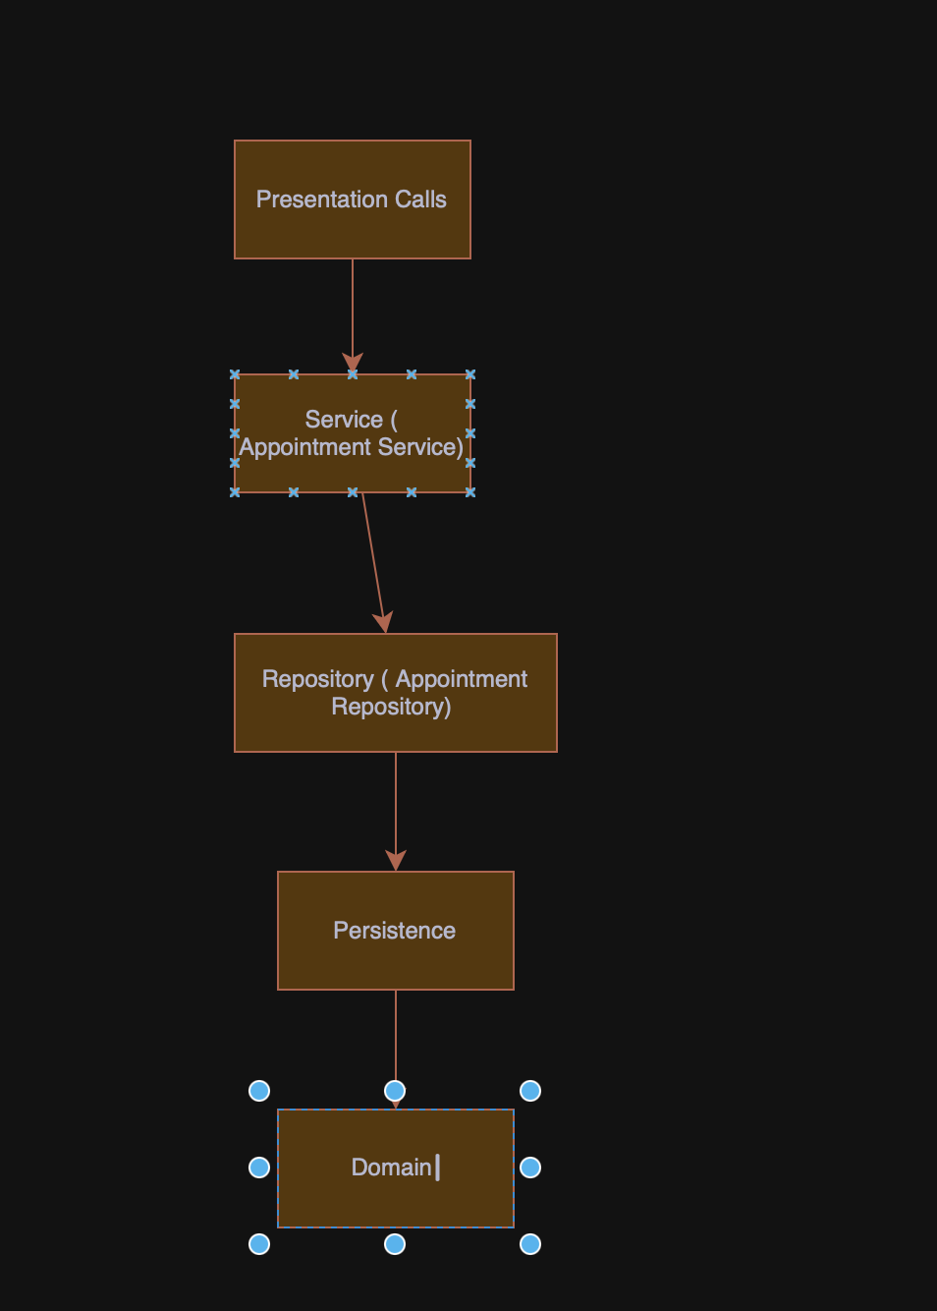

C - Create Package Structure
Create domain/, services/, repositories/, persistence/ and presentation/ or a justified equivalent.
SmartCare///
Domain/
Patient.py
Practitioner.py
Appointment.py
Persistence/
IN_memory_appointment_repsository.py
Cli.py
Presentation/
Appointment_repository.py
Repositories/
Appointment_service.py
Services/

D - Introduce AppointmentService
Move workflow coordination into a focused service without stealing Appointment domain behaviour.

E - Repository Abstraction
Define a small AppointmentRepository contract using only current use-case needs.

F - AI Architecture Review
Ask AI to review dependency direction, misplaced responsibilities and unnecessary complexity; request simplest justified improvements.
AI Finding | Assessment
No repository abstraction | Valid — data access should be behind an interface.
Workflow coordination missing | Valid — booking and overlap checking need a service.
Suggested adding SQLAlchemy | Premature — not justified by current requirements.
Suggested event bus for notifications | Rejected — notifications are provisional.
Suggested abstract base for Patient and Practitioner | Unjustified — no shared behaviour requires it.

G - Refactor and Verify
Apply only justified changes and confirm required behaviour remains unchanged.
Changes Made to the system
- overlaps() added to Appointment.
- AppointmentRepository abstract contract defined.
- InMemoryAppointmentRepository implements the contract.
- AppointmentService coordinates booking and cancellation without owning domain rules.

Verification:

H - Reflection
Document one AI suggestion accepted, one modified and one rejected/deferred.
Item | Decision
Accepted | Repository abstraction — keeps domain and persistence separate and makes testing straightforward.
Modified | Overlap check — AI placed it in the service; moved to Appointment.overlaps() because it uses appointment-level data.
Rejected | SQLAlchemy, event bus and shared base class — none are justified by confirmed requirements at this stage.

Suggested AI prompt
Act as a software architecture reviewer. Review this small SmartCare Python system against separation of concerns, cohesion, coupling and introductory SOLID principles. Identify concrete layer violations and dependency risks. Prefer the simplest refactoring that solves an observed problem. Do not introduce frameworks, microservices or patterns unless current requirements justify them.

